**E-LOK GEET**

**Submitted to**

**International Institute of Professional Studies**

**Devi Ahilya University**

**Indore**

**2014**

Partial Fulfilment

**For X semester of**

**Master Of Technology(IT) (5 ½** **years)**

**Guided by: Submitted By:**

Mr. Shaligram Prajapat Ashwini Varma (IT-2K9-07)

Keshav Patidar (IT-2K9-20)

Prathmesh Dubey (IT-2K9-29)

**CERTIFICATE**

This is to certify that the project report entitled “E-LOK GEET” carried out by Ms. Ashwini Varma (IT-2K9-07), Mr. Keshav Patidar (IT-2K9-20) and Mr. Prathmesh Dubey (IT-2K9-29), is approved for the acceptance in partial fulfilment of X semester of Master of Technology(IT) **5 ½** years.

Internal Examiner: External Examiner:

Project Incharge:

**DECLARATION**

We hereby declare that the project entitled “E-LOK GEET” which is submitted by us for the completion of the requirement for X semester of Master of Technology (Information Technology) 5 ½ Years to International Institute of Professional Studies, Devi Ahilya Vishwavidyalaya, Indore. This work has not been submitted anywhere else and comprises of our own work and due acknowledgement has been made in text to all in other materials used.

Signature of Student:

Ashwini Varma :

Keshav Patidar :

Prathmesh Dubey :

Date:

Place:

**ACKNOWLEDGEMENT**

We acknowledge our sincere thanks to those who have contributed significantly to this project. It is a pleasure to extend deep gratitude to our internal guide Mr. Shaligram Prajapat Sir, IIPS, for his valuable guidance and support and continuously inspired us for the progress of the project. We thank him for his valuable suggestions towards our project, which helped us in making this project more efficient and user friendly.

We thank and acknowledge each and every ones efforts that helped us in some or the other way for small and significant things.

Lastly we thank our parents who always motivated and stood by us, without their blessing and constant support the project couldn’t have been completed within due period.

**TABLE OF CONTENTS**

|  |  |
| --- | --- |
| **Topic** | **Page No.** |
| 1. Abstract    1. Abstract 2. Introduction    1. Introduction    2. Objectives       1. Business Goals and Objectives       2. Project Goals and Objectives    3. Assumptions 3. Project Justification    1. Working of Existing System    2. Proposed System As Solution    3. Proposed System Justification 4. System Analysis    1. SRS Document       1. Product Overview       2. Purpose       3. Scope       4. Functional Requirements       5. Non Functional Requirements          1. Performance Requirements          2. External Interface Requirements          3. Design Constraints    2. Gantt Chart    3. Hardware Requirement    4. Software Requirement    5. Information Gathering    6. Feasibility Analysis       1. Economical Feasibility       2. Technical Feasibility       3. Behaviour Feasibility    7. Technology    8. Team Structure 5. System Design    1. Purpose of Design    2. Activity Diagram    3. Sequence Diagram    4. Data Flow Diagram       1. Context Data Flow Diagram       2. Level 1 Data Flow Diagram    5. Class Diagram    6. Entity Relationship Diagram    7. Conceptual Data Design    8. Physical Data Design    9. Input Output Design    10. User Interface Design 6. Testing and Implementation    1. Testing Strategies    2. Levels of Testing    3. Testing Techniques    4. Test Cases    5. Software Quality Assurance    6. Screen Shots 7. Conclusion    1. Conclusion 8. Bibliography    1. Books and Manuals    2. Web Resources | 8 - 9  9  10 - 12  11  11 - 12  11  12  12  13 - 15  14  14 - 15  15  16 - 25  17 - 22  17  17  17 - 18  18 - 19  20 - 22  20  21  21 - 22  22  23  23  23  24  24  24  24  25  25  26 - 42  27  28 - 33  34 - 35  36 - 38  36  37 - 38  39  40  40  41 - 42  42  42  43 - 54  44  44 - 45  45 - 46  46- 47  48  49 - 56  57 -58  58  59 - 60  60  60 |

**ABSTRACT**

This project involves creation of E-Lok Geet for which facilitates online music listening and downloading concept.

There are seven modules in this E-Lok Geet They are :

* User Authentication
* Download Songs
* Listen Songs
* Feedback Management
  + Give Feedback
  + View Feedback
  + Reply for Feedback
* Songs Management
  + Upload Songs
  + Delete Songs
* Manage Favourite Songs List
  + Link Songs with particular User.
  + Unlink Songs that are linked with particular user
* Manage Account
* Change User Roles

**INTRODUCTION**

This project is made for lok (folk) music lovers who would like to listen to music anytime. Presently they issue is that lok (folk) music could not be made available everytime to users. Moreover, latest songs are not available with users. So there is a need for system which can provide users with latest songs. and can make lok (folk) music available to them everytime.

In existing system, users use music CDs or computer hard disk to store songs. So they have to carry these CDs or hard disk and song playing instruments like CD player or laptop with them to listen to songs. In this, it is difficult to organise songs, moreover users cannot keep these things all the time with them. So, music is not available to them all the time. And as new songs arrives more music CDs are needed to be purchased which increases users expense. And music CDs can also get easily damaged resulting in loss of data (songs).

The Purpose of E-Lok Geet is to overcome the entire problem which users are currently facing by making online lok (folk) music available to user.

**OBJECTIVES**

1. **Business Goals and Objectives :**

The business goals and objectives for this project will focus on implementing E-Lok Geet process that:

* Make Songs (Lok Geet) available to user anywhere and anytime for listening as well as for downloading.
* Facilitates effective way of organising songs (according to their movies/albums).
* Facilitates user to manage their favourite songs list in an efficient manner.
* Facilitates availability of latest songs too.
* Facilitates feedback system so that this system can be further improved.
* Facilitates platform or hardware independence. Any device with internet connection and speaker (like mobile phone, laptop, etc.) can use this system.
* Is easy to use.

1. **Project Goals and Objectives :**

* To provide all the requirements of the system in user friendly manner.
* Develop a plan for project execution to accomplish project business goals and objectives within time parameters.
* Provide security constraints like login page to ensure unauthorized access to data.
* To imbibe the beauty of JSP and MySQL but at the same time makes it user friendly for people unaware of its functionalities.
* To provide dynamic linking between web pages.
* Analyze whether the project is feasible in terms of technology, human resource and cost.

**ASSUMPTIONS**

The assumptions for the project are:

* The users should have some basic knowledge in operating computers.
* The HTML5 audio tag should be supported by client browsers to listen to songs online.

**WORKING OF EXISTING SYSTEM**

The current system used for listening music consists of mainly music CDs or hard disks.

Limitations of the current system are as follows:

* It is difficult to carry CDs or hard disk everywhere and everytime. So, music could not be made available at all the time
* The CDs or hard disk could get corrupt. This would result in loss of data (songs).
* A device like CD player or laptop which could read CD or hard disk is required to play songs.
* It is very difficult to organise songs with CDs.
* Manging favourite song list is difficult with CDs as favourite songs keep on changing. So, everytime new CD is to be made for favorite songs.
* Searching for particular song is very difficult task.
* For latest songs, new CDs are to be purchased which would increase user's expense.

**PROPOSED SYSTEM AS A SOLUTION**

The following points will give an overview of the proposed system:

* The proposed system will be a online web system.
* In addition to listening and download songs, the system will also provide facilities like feedback management, favourite song list management, account management,etc.
* The system will build in such a way that it avoids data redundancy. For example, username for logging in are unique and are related with one and only one user.
* It will be scalable so that in near future the system can be expanded.
* The system will also organise songs in very efficient manner based on the movie of particular song.
* The system will be reliable enough to perform in adverse conditions.
* The system will fulfil all necessary requirements of the end user as much as possible.
* The system will provide an error free environment.
* The system will provide a user-friendly interface with a realistic view.

**PROPOSED SYSTEM JUSTIFICATION**

The aim of the proposed system is to address the limitations of the current system. They are based on the requests and defects recorded in the past. Following is the justification for the proposed system:

* As it is web application. So, it will be available to user anywhere and anytime.
* It will reduce data duplication by use of RDBMS.
* It will implement validation techniques and checks that will help reduce the margin of error in operations.
* Since the system will have a RDBMS, searching and cataloguing of data (songs) will not be a problem. So, songs can be easily categorised on basis of their respective movies. Moreover, it will also facilitate favourite songs list management in an efficient manner.
* The system should produce reusable and extensible code i.e. provides facility to expand the system.
* The system will ensure data security using user authentication.

**SRS DOCUMENT**

# Product Overview

This Software Requirements Specification provides a complete description of all the functions and specifications of the E-Lok Geet needed by software engineers to adequately design and implement the software. Software Requirements Specification (SRS) completely describes all of the functions of a proposed system and the constraints under which it must operate.

## Purpose

In existing system, users use music CDs or computer hard disk to store songs. So they have to carry these CDs or hard disk and song playing instruments like CD player or laptop with them to listen to songs. In this system, it is difficult to organise songs, moreover users cannot keep these things all the time with them. So, music is not available to them all the time. And as new songs arrives more music CDs are needed to be purchased which increases users expense. And music CDs can also get easily damaged resulting in loss of data (songs).

The Purpose of E-Lok Geet is to overcome the entire problem which users are currently facing by making online music available to user.

## Product Scope

**In Scope :**

* Authentication : Admin/User have to login before accessing their respective features of E-Lok Geet.
* Listen Songs : Users/Guest can listen to songs online.
* Download Songs : Users/Guest can download songs.
* Upload Songs : New Songs can be uploaded by admin.
* Delete Songs : Corrupt or non-essential songs can be deleted in case of server overload by admin.
* Favourite Songs List : Users can manage their favourite songs list.
* Feedback Management : Users/Guest can give feedback and Admin can check the feedbacks and reply accordingly.
* Register : Guest can register to become member (user) of E-Lok Geet.
* Account Management : Users/Admin can manage their account details like Name, Authentication Password, etc.
* Change User Roles : Admin have authority to give another user admin privledges.

**Out Scope :**

* In E-Lok Geet only Lok Geet (Folk Songs) are present. That means, bollywook or hollywook songs are not present in E-Lok Geet.

1. **Functional Requirements**

**Use Case Diagrams**

* **For Admin**

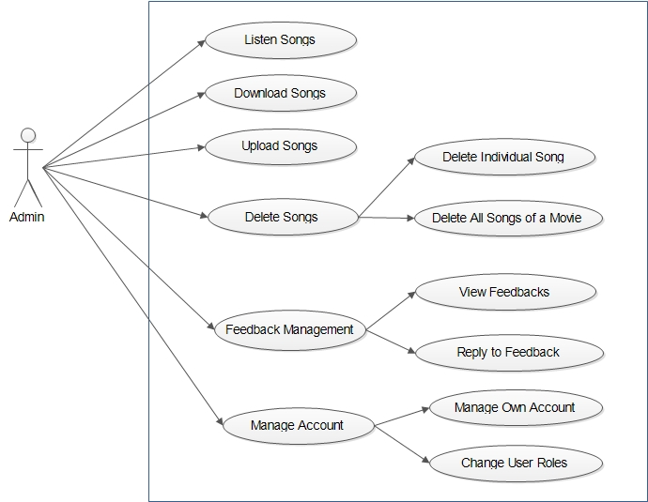

* **For User**

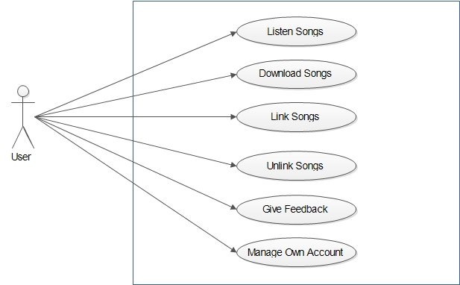

* **For Guest**

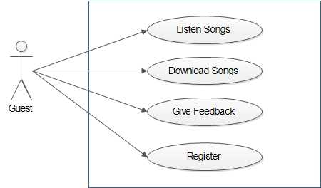

1. **Non-Functional Requirements**
   1. **Performance Requirement**
      1. **Static Requirements**

* Number of terminals supported : Multiple
  + One server for Database and for keeping Songs.
  + And any numbers of terminals can be used by users. As at any time any number of users should be able to use E-Lok Geet.
* Number of simultaneous users to be supported : Multiple
  + Database and Songs Administrator.
  + And any numbers of simuntaneous users should be supported by E-Lok Geet. As at any time any number of users should be able to use E-Lok Geet. In case, server starts getting overloaded due to many simuntaneous users. E-Lok Geet developers should keep in mind about future enhancements like increasing the number of servers or increasing the capacity of server.
    1. **Dynamic Requirements**
* Response Time : Response Time will depend on time in which data can be retrieved, updated or added to the database. Faster this will happen, lesser will be response time and more will be performance of the system. So for this, software developer should use powerful DBMS and powerful Server.

* Throughput constraints : Since, the data passing through the system will be in MBs in case of less simuntaneous users. But if number of simuntaneous users it can go to GBs. So, there is need for applying constraint on the data passing through the system. And this constraint is dependent on the Server capacity.
  1. **External Interface Requirement**
     1. **User Interface**

User Interface for this system should be a Web Application which should fulfill all the requirements of users. This Web Application can be implemented using technologies like JSP, HTML, CSS, JavaScript, etc. And Users can access E-Lok Geet using any web browser.

* + 1. **Hardware Interface**

The Server should be powerful enough to support multiple simuntaneous users. And Users can access E-Lok Geet only if they have Internet Connection.

* + 1. **Software Interface**

Software should be Web Application which is made to run on any platform.

* + 1. **Communication Interface**

The communication between End User Terminals and Database Server should be done through API which are in built with Front End of the software.

* 1. **Design Constraints**
     1. **Software Design Constraints**
* There are no constraints on program size and data size.
* As Software is to be made for any platform therefore, JSP would be preferred application to develop this software.
* As in this case response time is of major concern as multiple users would be simuntaneously giving request. So, the API which allows fastest communication between Database and user's request should be chosen. For example, in case JSP is being used, then Pure Java API should be used for database connectivity.
  + 1. **Hardware Design Constraints**
* Server have following configuration :
  + 4 GB RAM
  + 512 GB Hard Disk
  + Intel i7 Processor

**GANTT CHART**

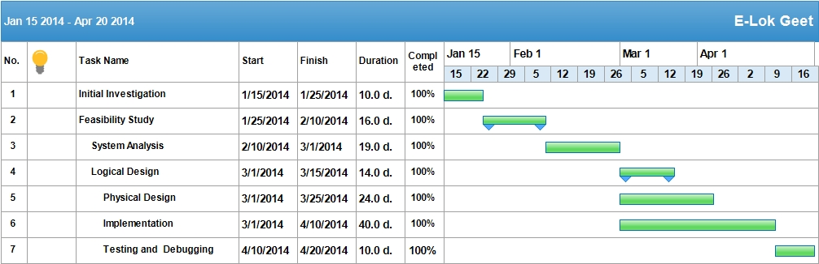

**HARDWARE REQUIREMENT**

Server should have atleast following configuration :

* 1 GB RAM
* 128 GB Hard Disk
* Intel Core 2 Duo Processor

Client should have :

* A device with Internet Connection and Speaker like Mobile Phone or Laptop

**SOFTWARE REQUIREMENT**

Software Requirements are as follows:

For Clients :

* Web Browser which supports HTML5 audio tag.

For Software Developer :

* NetBeans 7.3
* JDK 7
* JRE 7
* MySQL

**INFORMATION GATHERING**

Information gathering was done by analyzing previous processes used for listening music. And determining and understanding the defects of the existing system. And hence, deriving the solution to the defects of the existing system.

**FEASIBLITY ANALYSIS**

The most successful system projects are not necessarily the biggest or most visible in a situation but rather those that truly meet user’s expectations. To analyze the project’s feasibility is evaluated on the following grounds:

1. **Economic Feasibility**

As far as the benefits of the project are concerned the cost is quite negligible. The main cost is of the system used to access this project. But that does not concern us as the systems that are used to access the project will be clients systems. Hence, this project is economically feasible.

1. **Technical Feasibility**

This project is technically feasible as it has got all features necessary to form a healthy environment for communication. The concepts and technology used in this project are perfectly well and secure. And all the requirements of the system can be implemented. Any user having basic computer knowledge can access this project and make full use of it.

1. **Behaviour Feasibility**

People are inherently resistant to change, and computers have been known to facilitate change. An estimate should be made of how strong a reaction the user is likely to have towards the development of the computer system. It is common knowledge that computer installations have something to do with the turnovers, transfers, retaining and changes. But since now a days most of the people are familiar with the basic use of computers and since this project is being made in very user friendly way so that anyone with basic knowledge of computer can use it, so this project implementation will not hamper the environment.

**TECHNOLOGY**

The following technology has been used in the creation of this project:

* Server Side : JSP (Java Server Pages)
* Designing : HTML, CSS, Flash
* Client Side Scripting : JavaScript
* Relational Database Management System : MySQL
* Implementation Software : NetBeans 7.3

**TEAM STRUCTURE**

The project team consists of:

* Ashwini Varma (IT-2K9-07)
* Keshav Patidar (IT-2K9-20)
* Prathmesh Dubey (IT-2K9-29)

**PURPOSE OF DESIGN**

The purpose of this software design document is to provide a low-level description of the

E-Lok Geet, providing insight into the structure and design of each component. This document aids in following manners :

* Following design principles promotes better understanding of requirements, cleaner designs, and more maintainable systems.
* Here the software is organized as a collection of discrete object that incorporate both data structure and behaviour.
* The essence of development (analysis, design and development) is the identification and organization of application-domain concepts.
* This development approach encourages software developers to work and think in terms of the application through most of the software development life cycle.
* Its greatest benefits come from helping to express abstract concepts clearly and communicate them to each other.
* It can serve as a medium for specification, analysis, documentation and interfacing as well as for programming.
* In short, this document is meant to equip the reader with a solid understanding of the inner workings of the E-Lok Geet.

**ACTIVITY DIAGRAM**

* **Activity Diagram Symbols :**

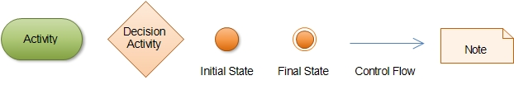

* **Activity : Play or Download Songs**

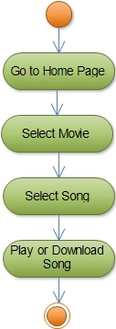

* **Activity : Register**

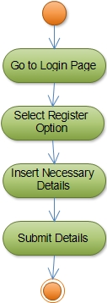

* **Activity : Give Feedback**

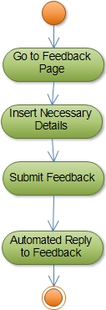

* **Activity : Upload Songs**

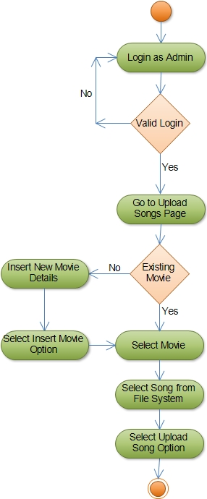

* **Activity : Delete Songs**

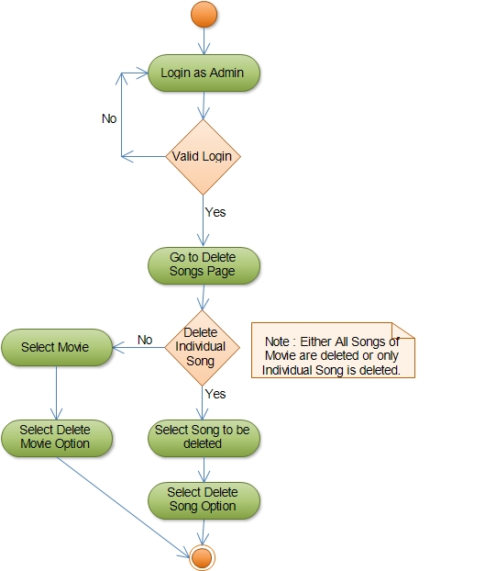

* **Activity : Feedback Management**

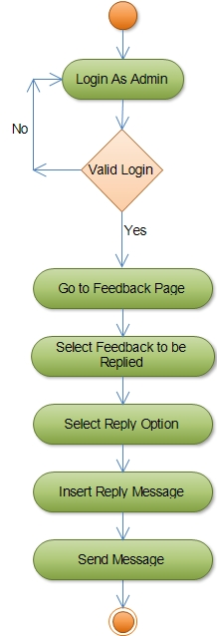

* **Activity : Change User Roles**

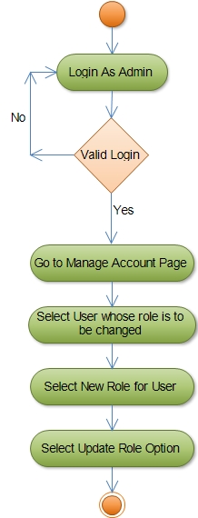

* **Activity : Link Songs**

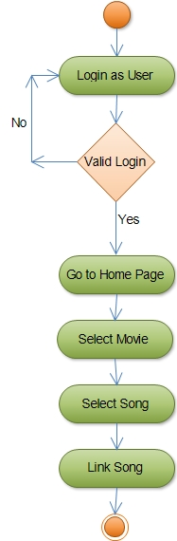

* **Activity : Unlink Songs**

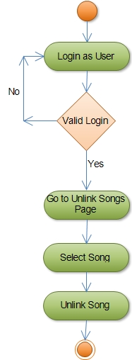

* **Activity : Manage Own Account**

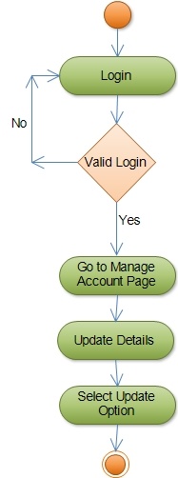

**SEQUENCE DIAGRAM**

* **For Admin**

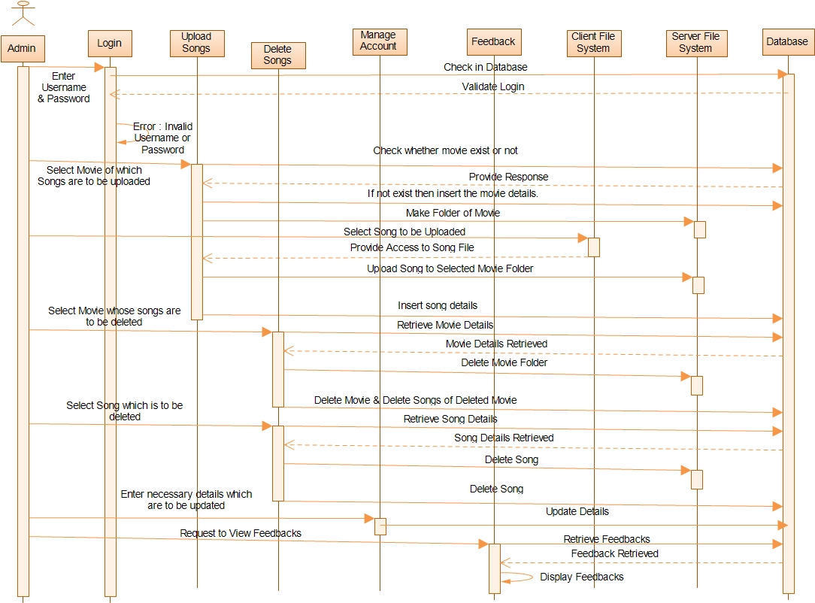

* **For User**

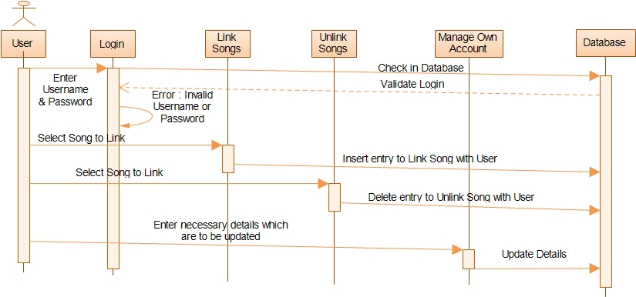

* **For Guest**

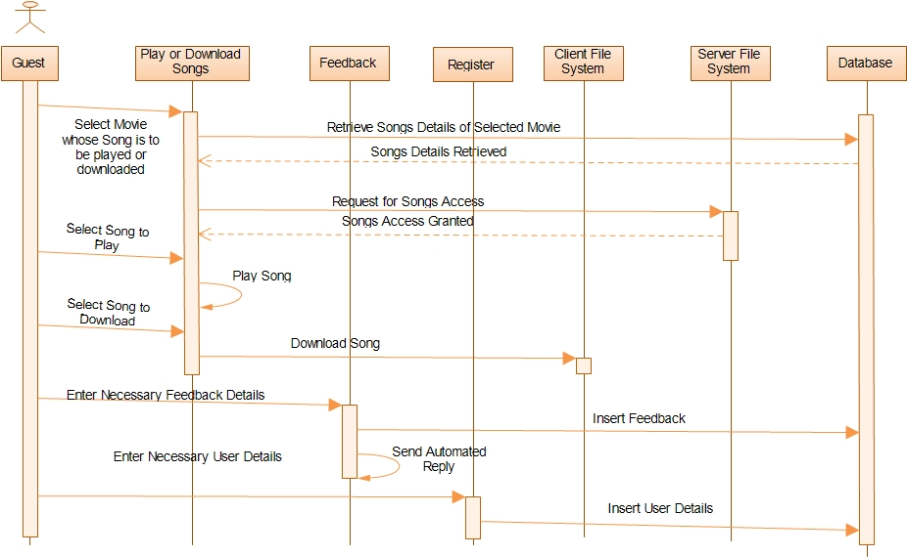

**DATA FLOW DIAGRAM**

* **Data Flow Diagram Symbols**

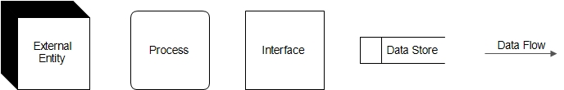

* **Context Data Flow Diagram**

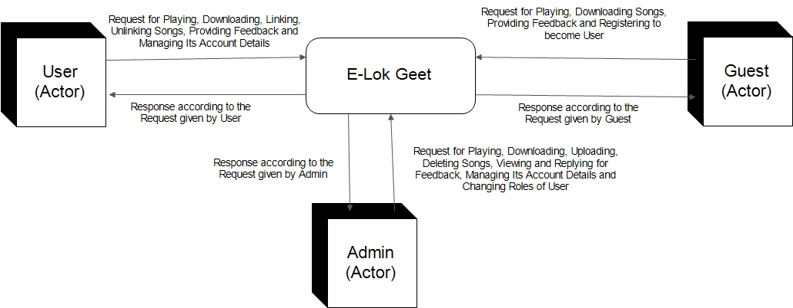

* **Level 1 Data Flow Diagram**

**For Admin**

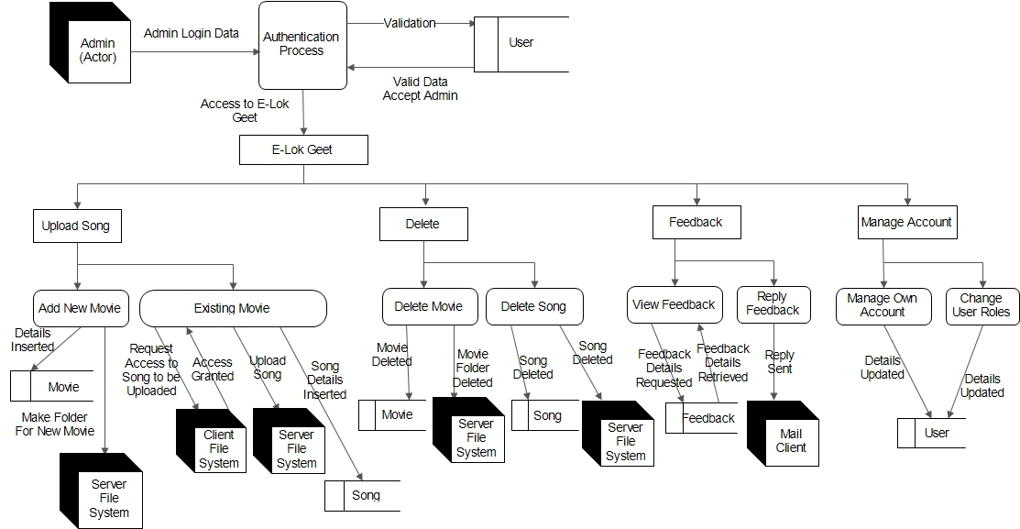

**For User**

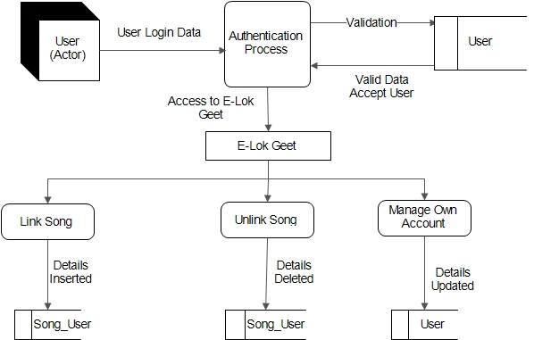

**For Guest**

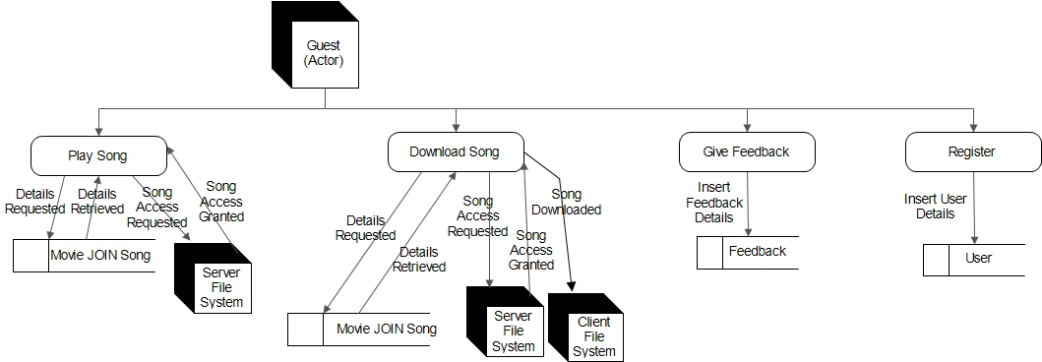

**CLASS DIAGRAM**

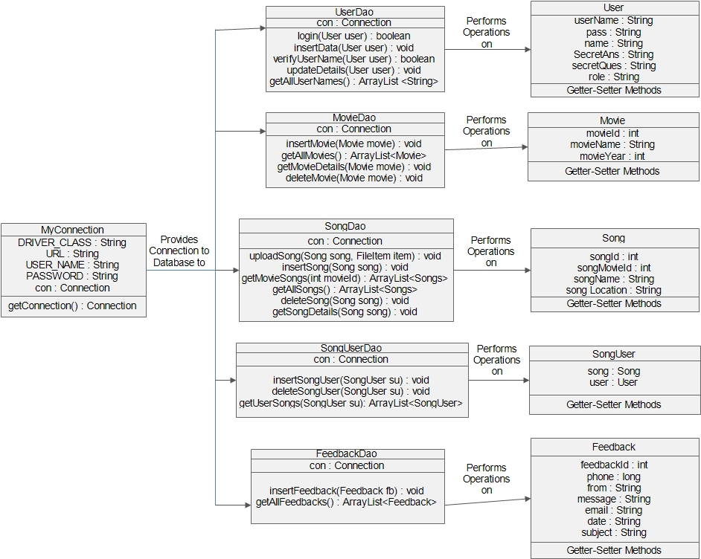

**E-R DIAGRAM**

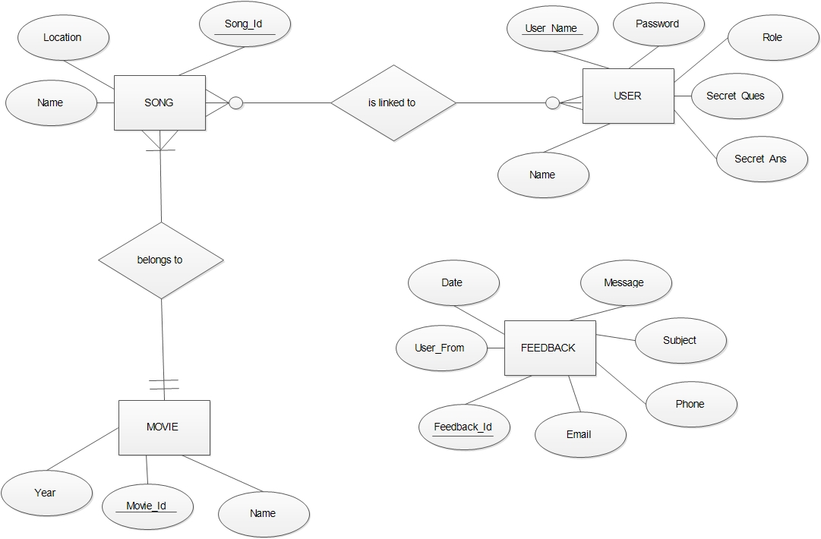

**CONCEPTUAL DATA DESIGN**

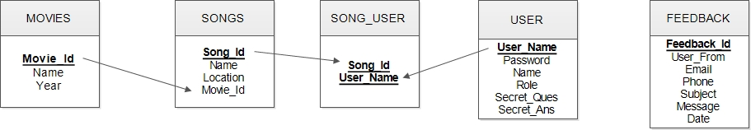

**PHYSICAL DATA DESIGN**

**USER TABLE**

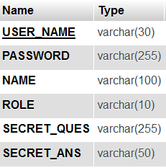

**MOVIES TABLE**

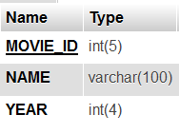

**SONGS TABLE**

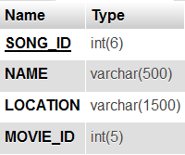

**SONG_USER TABLE**

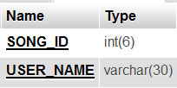

**FEEDBACK TABLE**

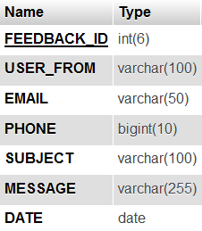

**INPUT OUTPUT DESIGN**

For any system to work properly it is very necessary to keep a check over the input and output of the system. In this system, we have used relational database management system (MySQL) for storing and sending information. So, it imposes an additional constraint that the data inputted by the user should conform to the standards for insertion of data into database.

**USER INTERFACE DESIGN**

Any project how so ever good it may become failure if the end user, it is meant to client cannot use it. For the end user to reap full benefits of the project, the project should have a good interface. Interface is the way a project links with the end user; it accepts the inputs from the user and gives output to the user. For a project, to be successful it should have a clean and understandable interface.

Properties of good interface are as follows:

* It should not be too bright in colours.
* The text written should be clear.
* Proper labelling should be done on labels and buttons.
* It should have minimum number of Data Input Facility i.e. most of the work must be done with List Box, Check Box, Combo Box, Radio Button, Hyperlinks etc.
* Proper messages/warnings should be provided to the user at all levels.

**TESTING STRATEGIES**

* The system development phases involve many activities where chances for occurrence of human errors are very large.
* Carelessness, improper documentation, the need to hurry through the whole process of software development due to time constraint, cost constraint etc. Provide ways for errors to creep in.
* The system must be tested thoroughly so that such errors are detected and corrected as early as possible.
* A successful test is one that uncovers every possible error.
* Large systems are built out of sub-systems which are in turn built out of modules.
* The testing process therefore proceeds in stages.

**LEVELS OF TESTING**



As can be inferred from figure, the testing process is an iterative one, with information being fed back from late stages to earlier parts of the process repeatable.

The four stages in the testing process are as follows:

1. **Unit testing: -** Individual functions or procedures are tested to ensure that they are operating correctly. Each component is tested individually.
2. **Module testing:** - A module is a collection of dependent components such as an object class, procedures and functions. A module encapsulates related components so that it can be tested without other system modules.
3. **Sub-System testing: -** Sub-System testing involves testing a collection of modules which have been integrated into sub-systems. Note that sub-systems may be independently designed and implemented. The most common problem which arises in large systems is the interfacing of the sub-systems. The sub-systems test process should therefore concentrate on the detection of interface errors by rigorous testing.
4. **System testing:** - The sub-systems are connected together to make the whole system. System testing process is concerned with finding such errors which do result from interaction / interfacing among sub-systems. System testing would be concerned with checking that the system meets the organization’s objective.

**TESTING TECHNIQUES**

1. **White Box Testing:-**

* White-box testing is concerned with the implementation of the program. In this type of testing, different programming and data structures used are tested for proper operations.
* This test concentrates on the examination of the coding. The system designer and programmers coin test-cases and test data to find out possible errors.

1. **Black Box Testing:-**

* Black-box testing is concerned with the proper testing and execution of the program specifications.
* In this type of testing, each function or sub-program used in the main program is first identified.
* Black-box is complementary to white-box techniques.
* This type of testing attempts to find the following errors:
  + Interface errors
  + Incorrect or missing functions.
  + Errors in external database access
  + Performance errors
  + Initialization and termination errors

1. **Alpha Testing:-**

* Tests performed at the developer’s site before the system is finally installed in the real working environmental (user’s site) is known as Alpha testing.
* It involves testing the system with live data supplied by the organization rather than by the test data used by system designer.

**TEST CASES**

1. **Login**

|  |  |
| --- | --- |
| Test Case | Expected Outcome |
| Valid Login Id and Password | If Login Id is of Admin then redirect to Admin Home Page else redirect to User Home Page. |
| Invalid Login Id or Password | Display Error Message on Login Page |

1. **Register**

|  |  |
| --- | --- |
| Test Case | Expected Outcome |
| Valid Details required for registration | Data should be inserted in database. And Message should be provided that registration successful. |
| Invalid Details inserted | Display Error Message on Register Page |

1. **Insert New Movie/Album**

|  |  |
| --- | --- |
| Test Case | Expected Outcome |
| Valid Details required for registration | **Data should be inserted in database. And Message should be provided that movie inserted.** |
| Invalid Details inserted | **Display Error Message** |

1. **Upload Song**

|  |  |
| --- | --- |
| Test Case | Expected Outcome |
| Valid Song and its corresponding movie selected | **Data should be inserted in database as well as on server file system. And Message should be provided that song uploaded successful.** |
| Invalid Details inserted | **Display Error Message on Song Upload Page.** |

**SOFTWARE QUALITY ASSURANCE**

1. **Reliability**

* The system should provide mechanism to detect any invalid values and should be able handle exceptions very efficiently.
* Moreover, system should use powerful DBMS and Server which donot crash.

1. **Usability**

* This system should be very easy to use. It should use graphical user interface components like combo box, list, radio buttons, etc. which are very easy to understand by user.
* Moreover, songs should be categorized according to their movies. It will increase readability and decrease complexity of the system.

1. **Security**

* System should provide measures to prevent software from unauthorized access of data.

1. **Reusability**

* The software should be made on concept of Object Oriented Programming and Component Based Assembly so that its Components can be reused again.

1. **Correctness**

* System should also provide features to check integrity and consistency of data before adding, updating or deleting of data in database.
* System should provide user with exact amount of data which he seeks i.e. system should not provide user with any extra data nor it should provide user with less data.

**SCREEN SHOTS**

**Guest**

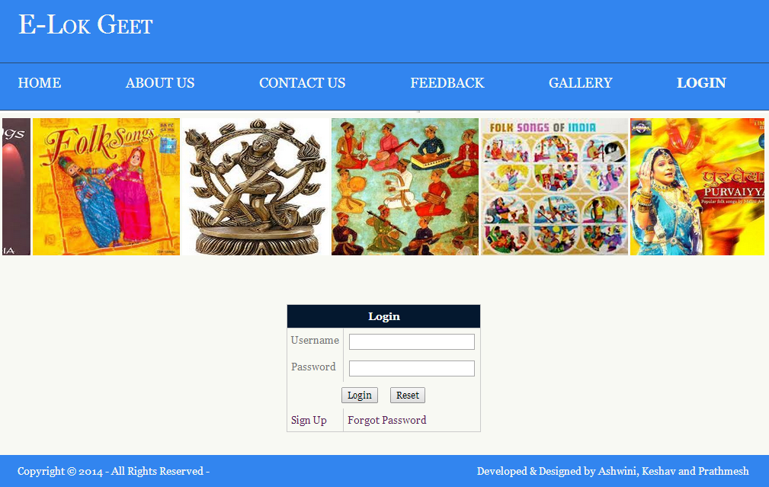

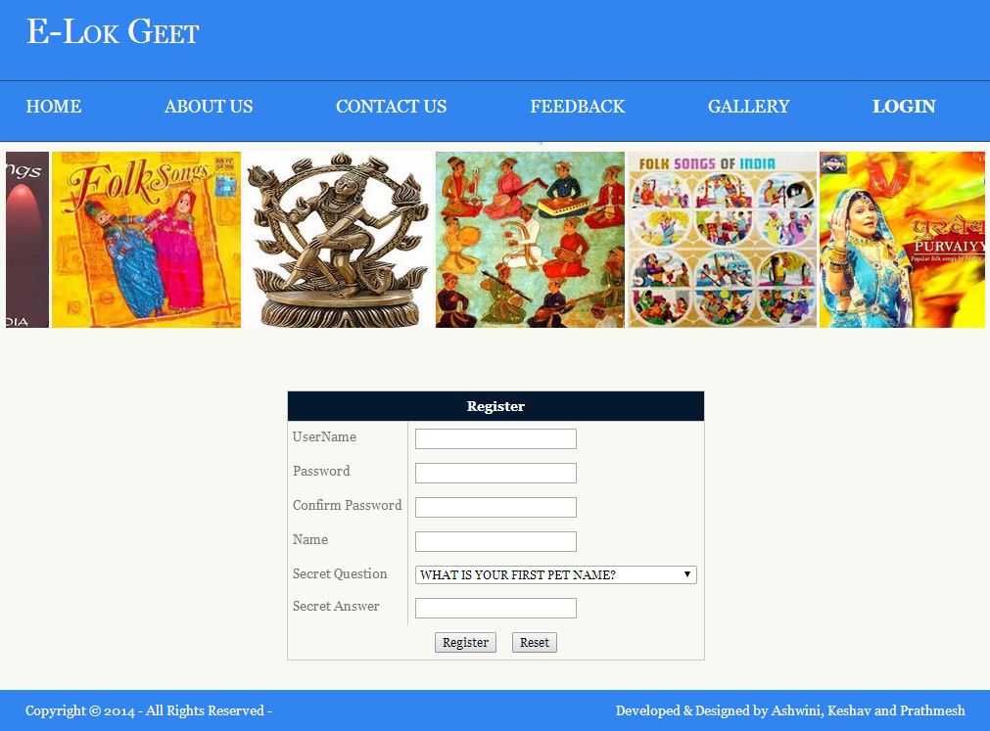

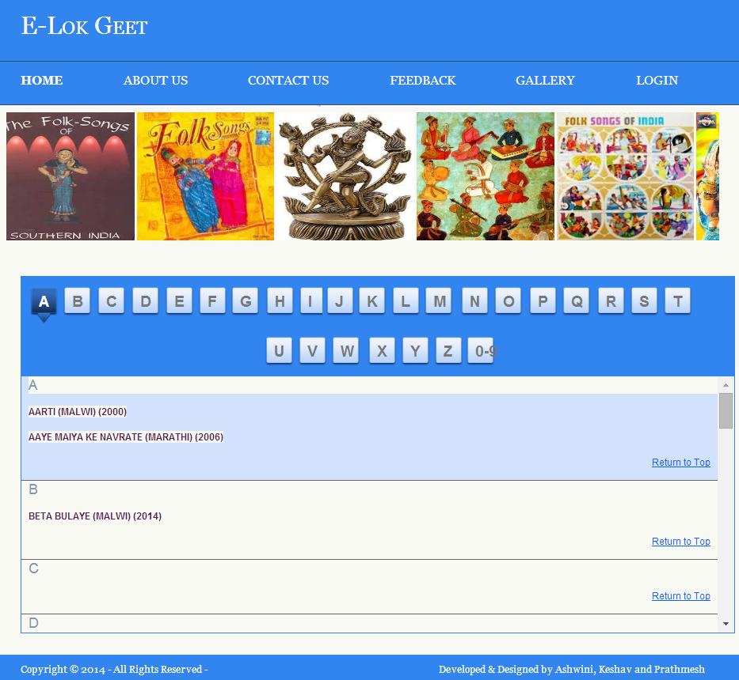

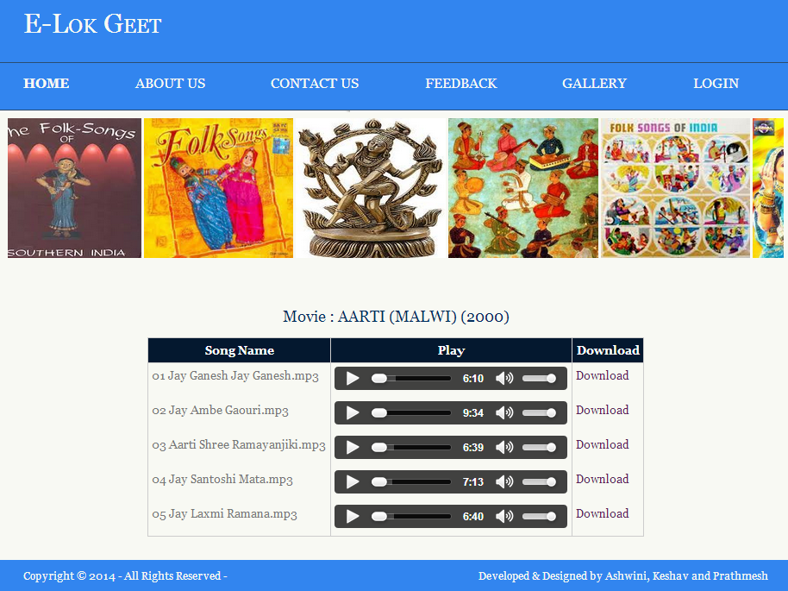

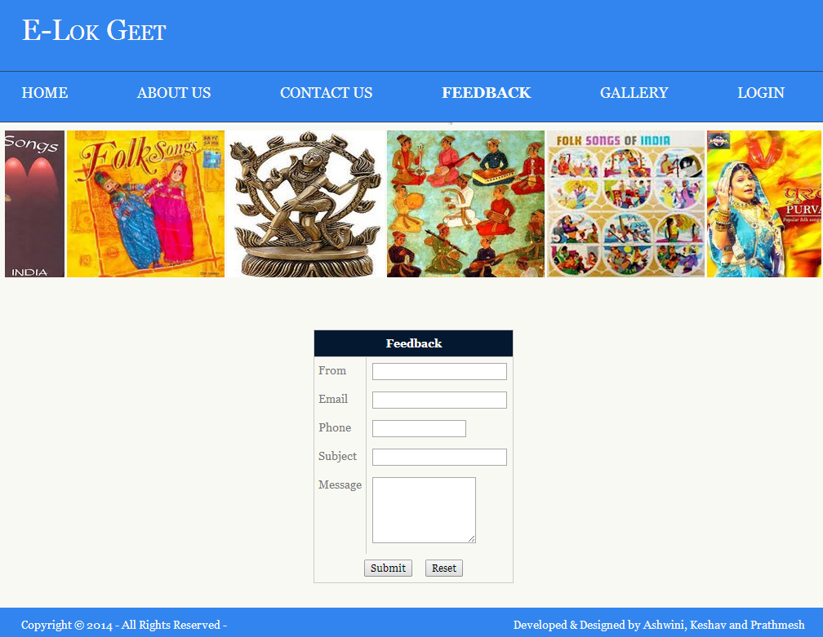

**User**

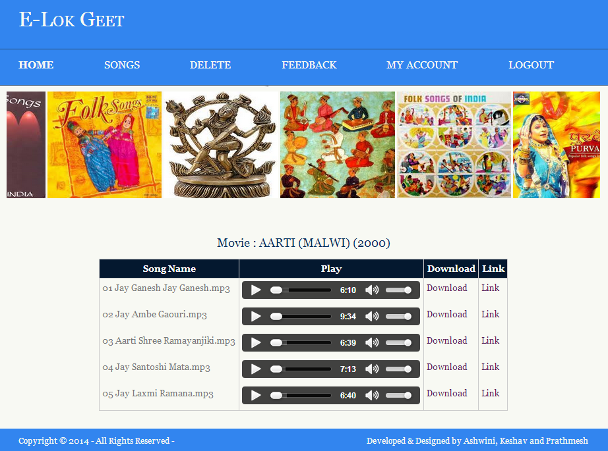

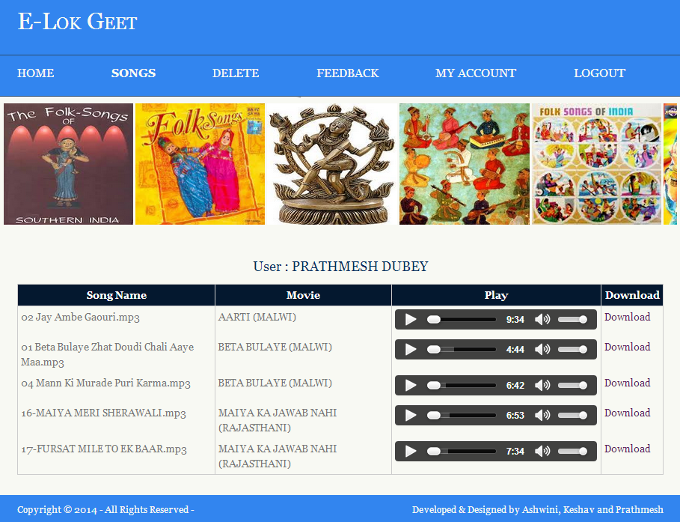

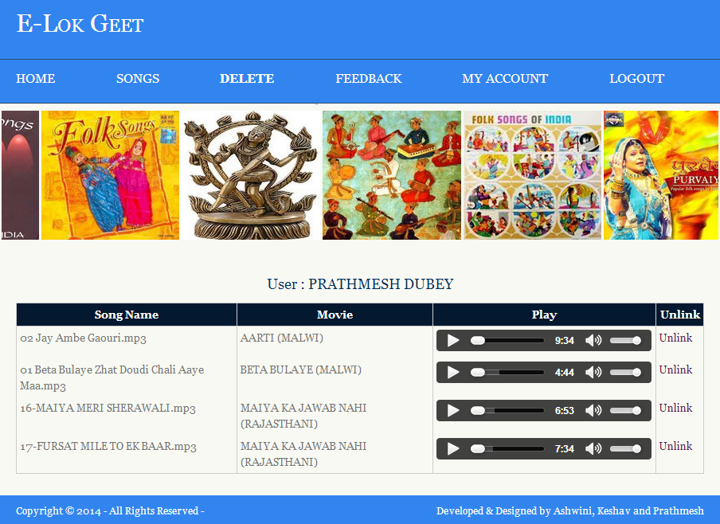

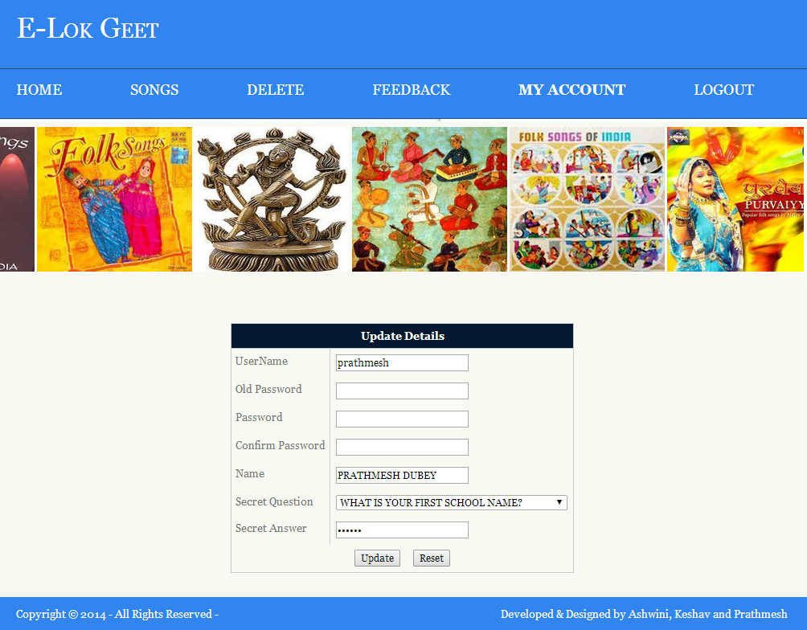

**Admin**

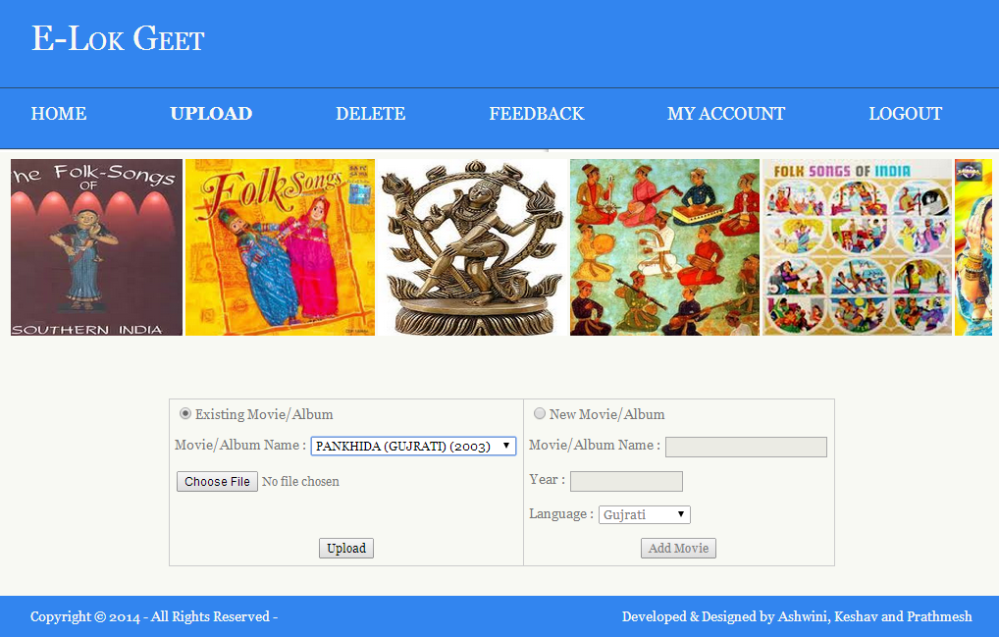

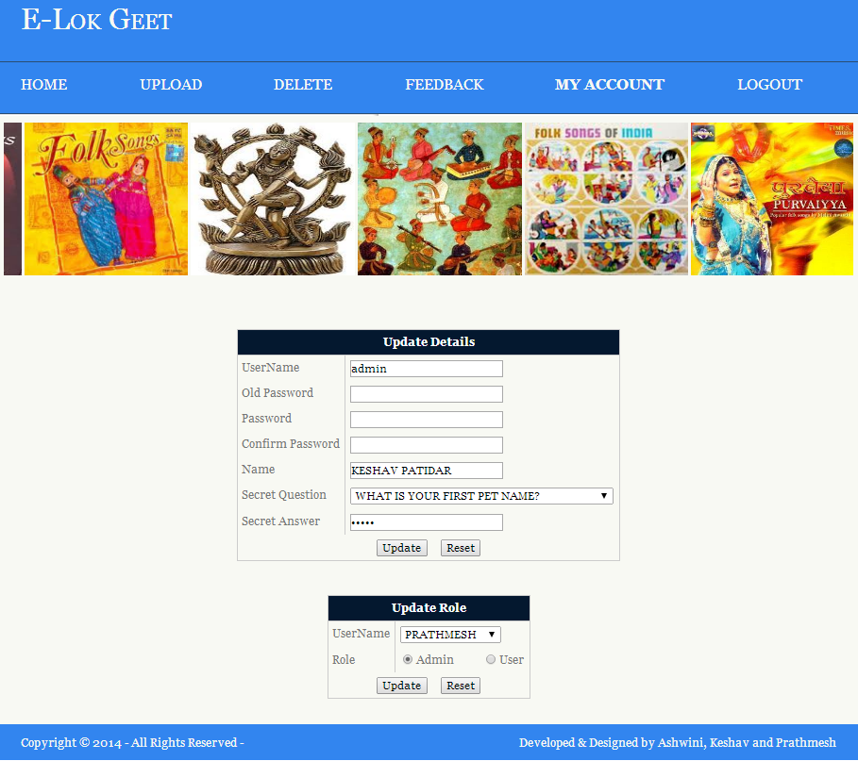

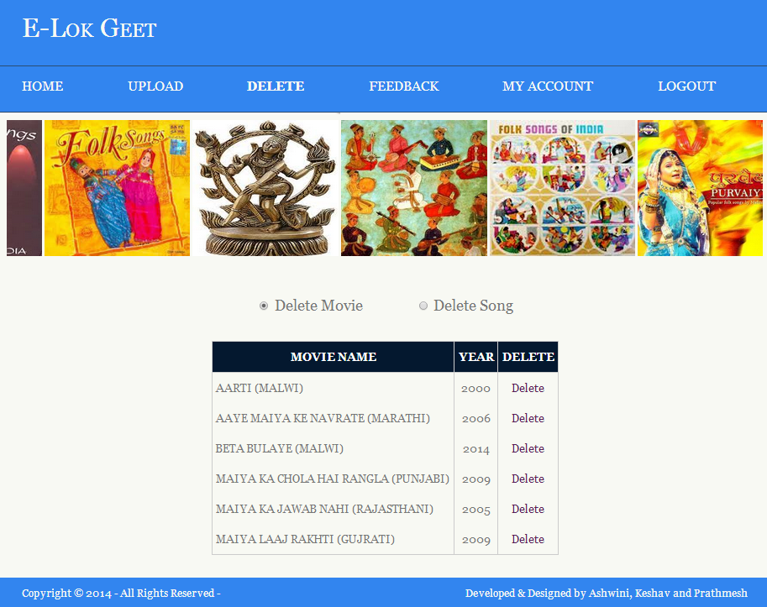

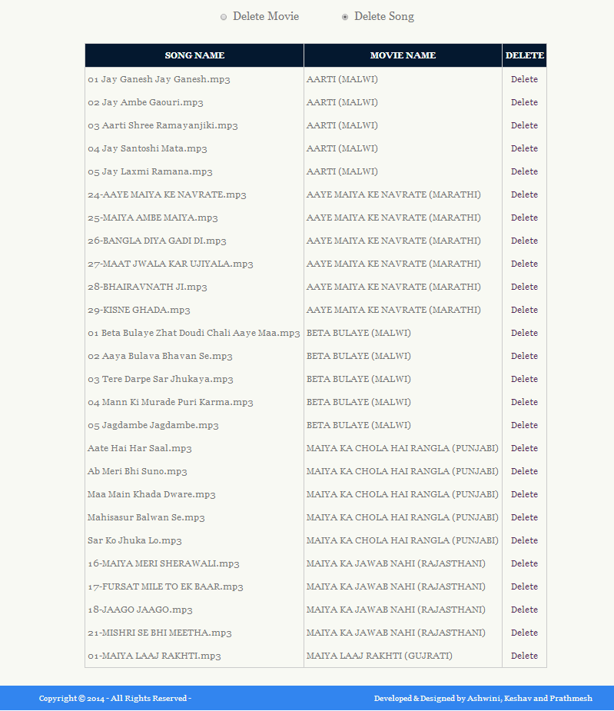

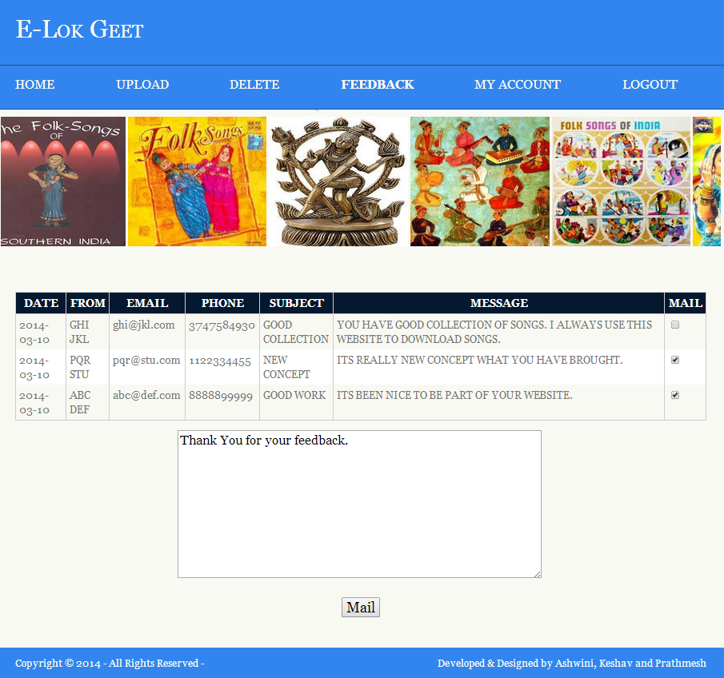

**CONCLUSION**

The software ‘E-Lok Geet’ reduces the considerable drawbacks. This software saves time and provides 24 hour accessibility even from a remote place. Programs are menu driven which help even a newcomer to use the system with little training. GUI makes the interface very much user friendly. The system is well efficient to ease interactions with the users of the system.

The system is done with an insight into the necessary modification that may require in the future. Hence the system can be maintained successfully, without much rework.

This project would remain a lifetime achievement to us for our future course of action. We have gained a lot of new thing & experience while doing this project work. The tools being used under the project provided us with an approach to solve any problem.

The platform of the project was quite interesting & challenging. Moreover, it helped us in carving our technical as well as creative skills.

**BOOKS AND MANUALS**

* System Analysis And Design by Elias M. Awad
* Java Servlets And JSP by Joel Murach and Andrea Steelman
* JAVA : How to Program by Deitel and Deitel
* MySql : The Complete Reference by Vikram Vaswani

**WEB RESOURCES**

* www.google.com
* www.answers.yahoo.com
* www.w3schools.com
* www.stackoverflow.com
* www.go4expert.com
* www.tutorialspoint.com/jsp/